Container Diagram

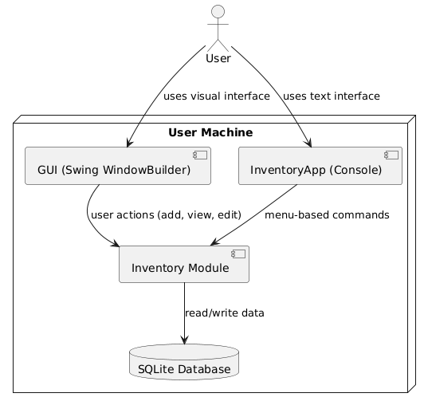

@startuml

!define RECTANGLE component

actor User

node "User Machine" {

RECTANGLE "GUI (Swing WindowBuilder)" as GUI

RECTANGLE "InventoryApp (Console)" as ConsoleUI

RECTANGLE "Inventory Module" as Logic

database "SQLite Database" as DB

GUI --> Logic : user actions (add, view, edit)

ConsoleUI --> Logic : menu-based commands

Logic --> DB : read/write data

}

User --> GUI : uses visual interface

User --> ConsoleUI : uses text interface

@enduml